VISVESVARAYA TECHNOLOGICAL UNIVERSITY
"Jnana Sangama", Belgaum: 590 018


A Mini Project report on
Hotel Management System
Submitted in partial fulfillment of the requirement for the award of Degree of
BACHELOR OF ENGINEERING
IN
COMPUTER SCIENCE AND ENGINEERING
By
Anoop C. A 1AY15CS015

Under the guidance of
Dr. Nagaveni V
Prof. Manujakshi B C
Prof. Ancy Thomas
Prof. Sowmya P


DEPARTMENT OF COMPUTER SCIENCE & ENGINEERING
ACHARYA INSTITUTE OF TECHNOLOGY
(Affiliated to Visvesvaraya Technological University, Belgaum)
2017-2018

ACHARYA INSTITUTE OF TECHNOLOGY
(Affiliated to Visvesvaraya Technological University, Belgaum)
Soladevanahalli, Bangalore – 560090

DEPARTMENT OF COMPUTER SCIENCE & ENGINEERING



Certificate

Certified that the Mini Project entitled Hotel Management System is a bonafide work carried out by Anoop C.A in partial fulfillment for the award of degree of Bachelor of Engineering in Computer Science & Engineering of the Visvesvaraya Technological University, Belgaum during the year 2017-2018. It is certified that all corrections/ suggestions indicated for internal assessments have been incorporated in the Report deposited in the departmental library. The Mini Project report has been approved as it satisfies the academic requirements in respect of Mini Project work prescribed for the Bachelor of Engineering Degree.

Signature of Guides Signature of H.O.D

Name of the examiners Signature with date

1.
2.
ACKNOWLEDGEMENT

I express my gratitude to our institution and management for providing us with good infrastructure, laboratory, facilities and inspiring staff, and whose gratitude was of immense help in completion of this seminar successfully.

I express my sincere gratitude to our principal, Dr. Sharanabasava C Pilli for providing me required environment and for his valuable suggestion.

My sincere thanks to Dr. Prashanth C M, Head of the Dept. Computer Science and Engineering, Acharya Institute of Technology for his valuable support and for rendering us resources for this seminar work.

I express my gratitude to Dr.Nagaveni V Associate Professor, Prof.Manujakshi B C, Prof.Ancy Thomas, Prof. Sowmya P Assistant Professors, Dept. Computer Science and Engineering, Acharya Institute of Technology who guided me with valuable suggestions in completing this seminar at every stage.

My gratitude thanks should be rendered to many people who helped me in all possible ways.

Anoop C.A
(1AY15CS015)

ABSTRACT
The objective of the project is to design Hotel Management System which enables the Manager to keep the record of the information regarding the hotel and customers.
The project has been designed in Php/Mysql and consists of a Sql Server which acts as the database for the project.
My motivation for the project came from my enthusiasm and strong urge to learn php and sql which is one of the fastest growing field in today’s world. The Hotel Management System consists of two types of users. The customer inserts the information and the administrator modifies and updates the information.
All the data needed for the application is stored in the form of tables in MYSQL server.
The report contains the details of all the tasks carried out during the entire development life cycle of the Hotel Management System. This document depicts all the details of the project.

TABLE OF CONTENTS
Chapter 1: Introduction
  - Description about Hotel Management System
  - Introduction to DBMS
Chapter 2: Software and Hardware Requirements
2.1 Software Requirements
2.2 Hardware Requirements
Chapter 3: Design
3.1 ER Diagram
3.2 Schema Diagram
Chapter 4: Implementation
4.1 Table Creation
4.2 Table Insertion
4.3 Table Queries
4.4 Triggers
4.5 Stored Procedure
Chapter 5: Snapshots
Conclusion and Future Enhancement
Bibliography

1.1 Introduction
Hotel Management System manages variety of tasks related to Hotel bookings. A hotel admin manages a guest’s check-in and checkout, cash transactions, outlet transactions, reservations etc. It impacts the rooms division during and after the arrival chronology.
The System is to manage all the Boarding and lodging activities of a hotel. It automates the task of room reservation, bill generation, checks room availability, etc. The overall Functioning of the system, schemas and its attributes are mentioned below.
Schemas:
Contact, Login, Newsletterlog, Payment, Room, Roombooking
Some objectives are-
No data duplication
No paper work required
Time Efficient
Cost Efficient
Automatic data validation
User friendly environment
Data security and reliability
Fast data insertion and retrieval
Easy performance check
Sample source code-
<?php
$con = mysqli_connect("localhost","root","","hotel") or die(mysql_error());?>
<?php
session_start();
if(isset($_SESSION["user"]))
{
header("location:home.php");
}

?>
<!DOCTYPE html>
<html >
<head>
<meta charset="UTF-8">
<title>SUN RISE ADMIN</title>

<link rel="stylesheet" href="css/style.css">

</head>

<body>
<div id="clouds">
<div class="cloud x1"></div>
<!-- Time for multiple clouds to dance around -->
<div class="cloud x2"></div>
<div class="cloud x3"></div>
<div class="cloud x4"></div>
<div class="cloud x5"></div>
</div>

<div class="container">

<div id="login">

<form method="post">

<fieldset class="clearfix">

<p><span class="fontawesome-user"></span><input type="text" name="user" value="Username" onBlur="if(this.value == '') this.value = 'Username'" onFocus="if(this.value == 'Username') this.value = ''" required></p> <!-- JS because of IE support; better: placeholder="Username" -->
<p><span class="fontawesome-lock"></span><input type="password" name="pass" value="Password" onBlur="if(this.value == '') this.value = 'Password'" onFocus="if(this.value == 'Password') this.value = ''" required></p> <!-- JS because of IE support; better: placeholder="Password" -->
<p><input type="submit" name="sub" value="Login"></p>

</fieldset>

</form>

</div> <!-- end login -->

</div>
<div class="bottom"> <h3><a href="../index.php">SUN RISE HOMEPAGE</a></h3></div>
</body>
</html>
<?php
include('db.php');
if($_SERVER["REQUEST_METHOD"] == "POST") {
// username and password sent from form

$myusername = mysqli_real_escape_string($con,$_POST['user']);
$mypassword = mysqli_real_escape_string($con,$_POST['pass']);

$sql = "SELECT id FROM login WHERE usname = '$myusername' and pass = '$mypassword'";
$result = mysqli_query($con,$sql);
$row = mysqli_fetch_array($result,MYSQLI_ASSOC);
$active = $row['active'];

$count = mysqli_num_rows($result);

// If result matched $myusername and $mypassword, table row must be 1 row

if($count == 1) {

$_SESSION['user'] = $myusername;

header("location: home.php");
}else {
echo '<script>alert("Your Login Name or Password is invalid") </script>' ;
}
}
?>

1.2 Introduction to DBMS
DBMS stands for Database Management System. We can break it like this DBMS = Database + Management System. Database is a collection of data and Management System is a set of programs to store and retrieve those data. Based on this we can define DBMS like this: DBMS is a collection of inter-related data and set of programs to store & access those data in an easy and effective manner. Database systems are basically developed for large amount of data. When dealing with huge amount of data, there are two things that require optimization: Storage of data and retrieval of data.
DBMS Languages
Data Definition Language (DDL)
Used by the DBA and database designers to specify the conceptual schema of a database.
• In many DBMSs, the DDL is also used to define internal and external schemas (views).
Data Manipulation Language (DML)
Used to specify database retrievals and updates DML commands (data sublanguage) can
be embedded in a general-purpose programming language (host language), such as
COBOL, C, C++, or Java.

Why Use DBMS?
- To develop software applications In less time.
- Data independence and efficient use of data.
- For uniform data administration.
- For data integrity and security.
- For concurrent access of data, and data recovery from crashes.
- To use user-friendly declarative query language.

Where is Database Management System (DBMS) being Used?
- Airlines: reservations, schedules etc
- Telecom: calls made, customer details, network usage etc
- Universities: registration, results, grades etc
- Sales: products, purchases, customers etc
- Banking: all transactions etc

Advantages of DBMS

A DBMS manage data and has many advantages. These are:
- Data independence: Application programs should be as free or independent as possible from details of data representation and storage. DBMS can supply an abstract view of the data for insulating application code from such facts.
- Efficient data access: DBMS utilizes a mixture of sophisticated concepts and techniques for storing and retrieving data competently and this feature becomes important in cases where the data is stored on external storage devices.
- Data integrity and security: If data is accessed through the DBMS, the DBMS can enforce integrity constraints on the data.
- Data administration: When several users share the data, integrating the administration of data can offer major improvements. Experienced professionals understand the nature of the data being managed and can be responsible for organizing the data representation to reduce redundancy and make the data to retrieve efficiently.

Components of DBMS
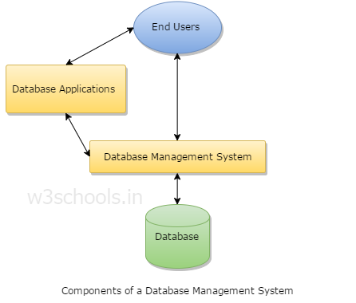
- Users: Users may be of any kind such as DB administrator, System developer or database users.
- Database application: Database application may be Departmental, Personal, organization’s and / or Internal.
- DBMS: Software that allow users to create and manipulate database access,
- Database: Collection of logical data as a single unit.

2.1 Software Requirements
User Interface: HTML, CSS
Client-side Scripting: JavaScript
Programming Language: PHP
Web Applications: WampServer 3.1.0 64-bit
IDE/Workbench: Notepad++
Database: Mysql
Server Deployment: Apache2.0

2.2 Hardware Requirements
Processor: Pentium III or higher
Ram:512Mb or more
Hard Disk: 20Gb or more
Browser: IE, Chrome, Mozilla Firefox etc
Operating System: Windows 7/8/8.1/10 or Linux

3.1 ER Diagram

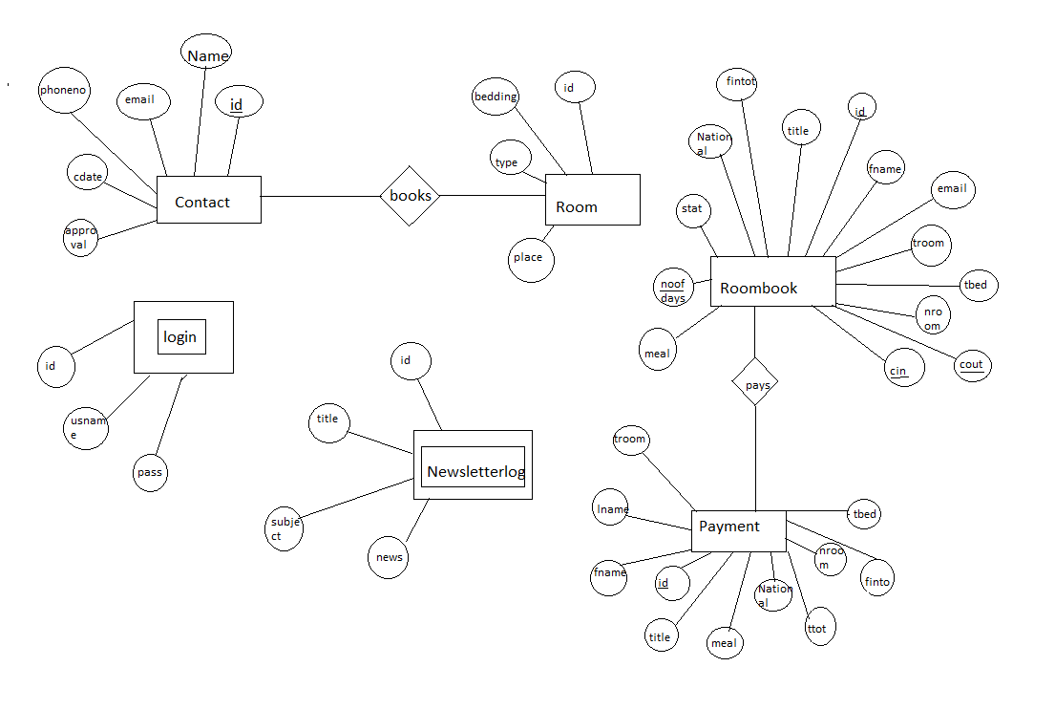

3.2 Schema Diagram

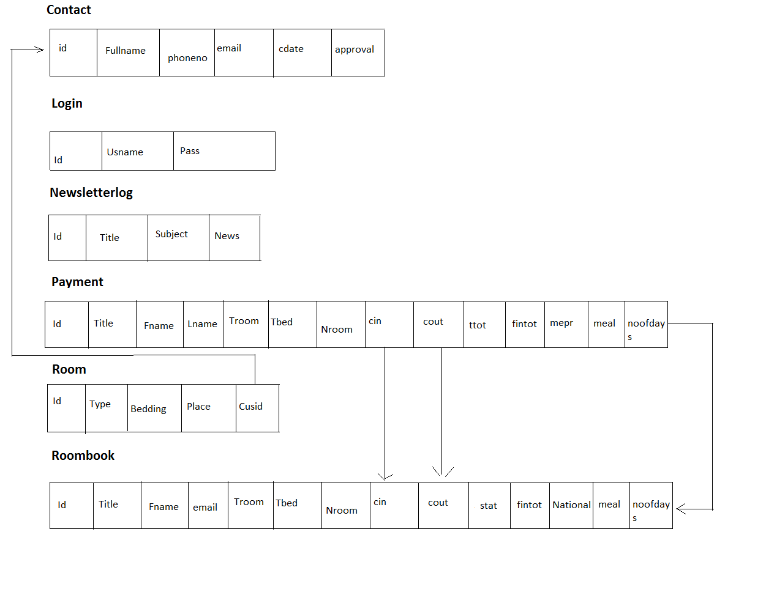

4.1 Table Creation
create table contact (id int, fullname varchar (100), phoneno int, email text, cdate date, approval varchar (12));
Column Name | Data Type | Null constraint | Key constraint
id | int | NOT NULL | Primary Key
Fullname | Varchar (100) | NOT NULL
phoneno | int | NOT NULL
email | text | NOT NULL
cdate | date | NOT NULL
approval | Varchar (12) | NOT NULL

create table login (id int, usname varchar (30), pass varchar (30));
Column Name | Data Type | Null constraint | Key constraint
Id | Int | NOT NULL | Primary Key
Usname | Varchar (30) | NOT NULL
Pass | Varchar (30) | NOT NULL

create table newsletterlog (id int, title varchar (52), subject varchar (100), news text);
Column Name | Data Type | Null constraint | Key constraint
Id | Int | NOT NULL | Primary Key
Title | Varchar (52) | NOT NULL
Subject | Varchar (100) | NOT NULL
News | Text | NOT NULL

create table payment (id int, title varchar (5), fname varchar (30), lname varchar (30), troom varchar (30), tbed varchar (30), nroom int,cin date, cout date,ttot double (8,2), fintot double (8,2),mepr double (8,2),meal varchar (30),noofdays int);

Column Name | Data Type | Null Constraint | Key Constraint
Id | Int | NOT NULL | Primary Key
Title | Varchar (5) | NOT NULL
Fname | Varchar (30) | NOT NULL
lname | Varchar (30) | NOT NULL
troom | Varchar (30) | NOT NULL
tbed | Varchar (30) | NOT NULL
nroom | int | NOT NULL
cin | Date | NOT NULL
cout | date | NOT NULL
ttot | Double (8,2) | NOT NULL
fintot | Double (8,2) | NOT NULL
mepr | Double (8,2) | NOT NULL
meal | Varchar (30) | NOT NULL
noofdays | int | NOT NULL

create table room (id int, type varchar (15), bedding varchar (10), place varchar (10), cusid int);
Data Type | Column Name | Null Constraint | Key Constraint
Id | Int | NOT NULL | Primary Key
Type | Varchar (15) | NOT NULL
Bedding | Varchar (10) | NOT NULL
Place | Varchar (10) | NOT NULL
Cusid | int | NOT NULL | Foreign Key

create table roombook(id int , Title varchar (5), Fname text, Lname text,Email varchar (50), National varchar (30),phone text ,troom varchar (10),bed varchar (10),nroom varchar (2),meal varchar (15),cin date, cout date, stat varchar (15),nodays int);
Data Type | Column Name | Null Constraint | Key Constraint
Id | int | NOT NULL | Primary Key
title | Varchar (5) | NOT NULL
fname | text | NOT NULL
lname | text | NOT NULL
email | Varchar (50) | NOT NULL
National | Varchar (30) | NOT NULL
phone | text | NOT NULL
troom | Varchar (10) | NOT NULL
bed | Varchar (10) | NOT NULL
nroom | Varchar (2) | NOT NULL
meal | Varchar (15) | NOT NULL
Cin | date | NOT NULL | Foreign Key
cdate | date | NOT NULL | Foreign Key
stat | Varchar (15) | NOT NULL
nodays | int | NOT NULL | Foreign Key

4.2 Table Insertion
Insert into roombook values (1,’Mr.’,’Anoop’,’Chipli’,’anoopssjchipli@gmail.com’,’Indian’,’India’,9448873942,’Single Room’,1,’room only’,’26-nov-2017’,’02-DEC-2017’,’Not Confirmed’,3);
Insert into roombook values (2,’Miss.’,’Nayana’,’Chandrashekhar’,’sss@gmail.com’,’Indian’,’Mexico’,8867572160,’Deluxe Room’,1,’Breakfast’,’01-Feb-2017’,’20-DEC-2017’,’Not Confirmed’,322);
Insert into roombook values (3,’Dr.’,’Vishnu’,’Vardhan’,’vv@gmail.com’,’Non Indian’,’United States’,9448873942,’Guest House’,1,’Full board’,’30-nov-2017’,’08-DEC-2017’,’Not Confirmed’,8);
Insert into login values (1,’admin’,’1234’);
Insert into login values (2,’prasath’,’12345’);
Insert into values (1,’Hi’,’Rent’,’Please pay’);
Insert into values (1,’Superior Room’,’Single’,’Free’,Null);
Insert into values (2,’Superior Room’,’Double’,’Free’,Null);
Insert into values (3,’Superior Room’,’Triple’,’Free’,Null);
Insert into values (4,’Single Room’,’Quad’,’Free’,Null);
Insert into values (5,’Superior Room’,’Quad’,’Free’,Null);
Insert into values (6,’Deluxe Room’,’Single’,’Free’,Null);
Insert into values (7,’Deluxe Room’,’Double’,’Not Free’,Null);
Insert into values (8,’Deluxe Room’,’Triple’,’Free’,Null);
Insert into values (9,’Deluxe Room’,’Quad’,’Free’,Null);
Insert into values (10,’Superior Room’,’Single’,’Free’,Null);
Insert into values (11,’Guest House’,’Single’,’Free’,Null);
Insert into values (12,’Guest House’,’Double’,’Free’,Null);
Insert into values (13,’Guest House’,’Triple’,’Free’,Null);
Insert into values (14,’Guest House’,’Quad’,’Free’,Null);

4.3 Table Queries
Insertion
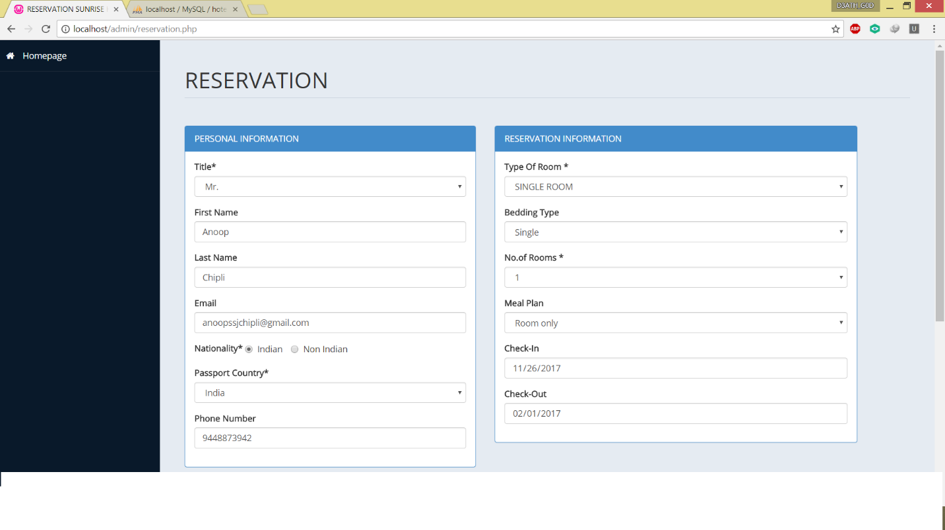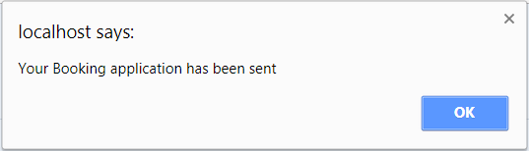
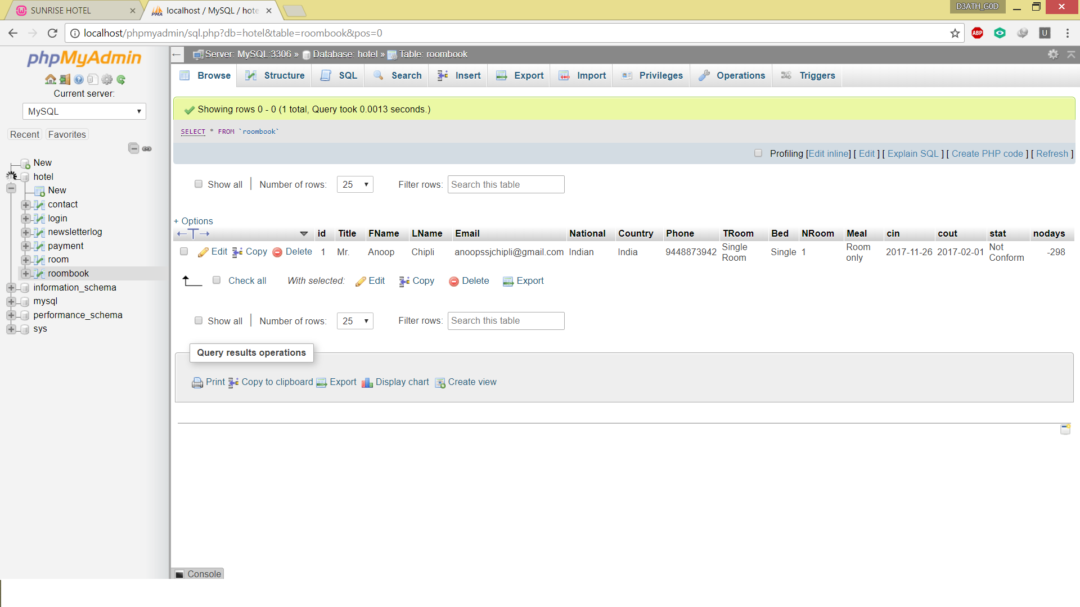

Deletion
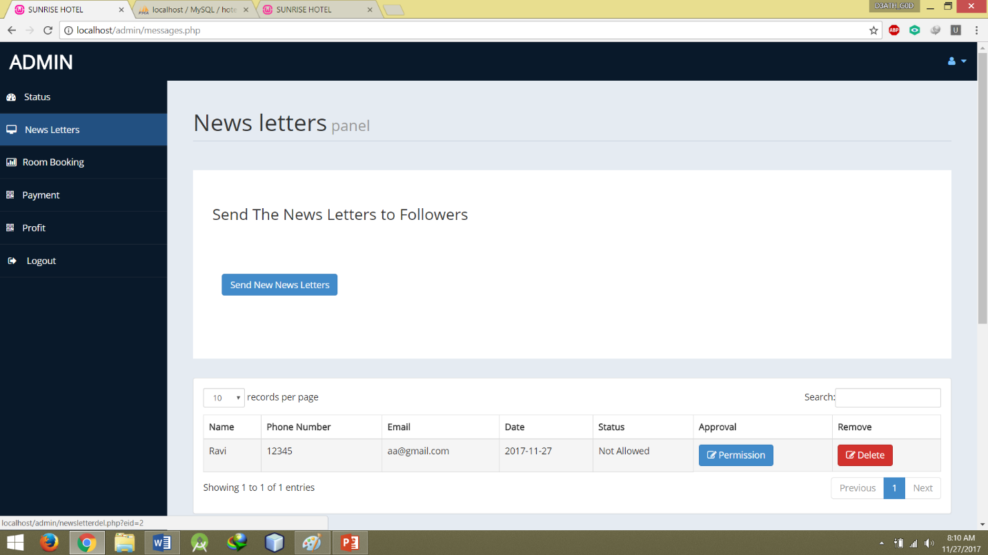
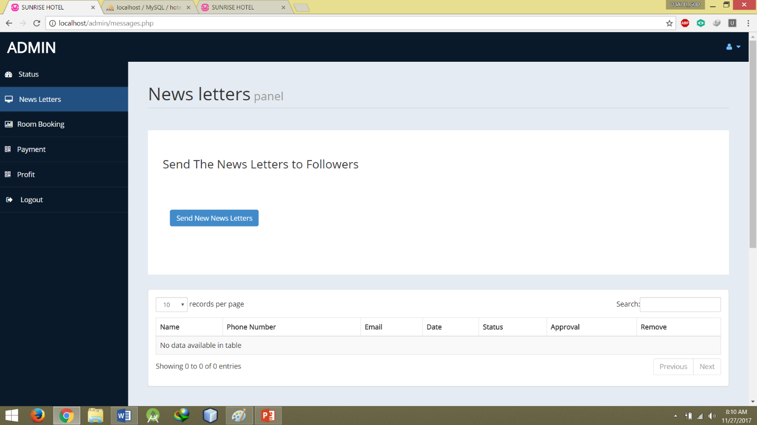
Updating
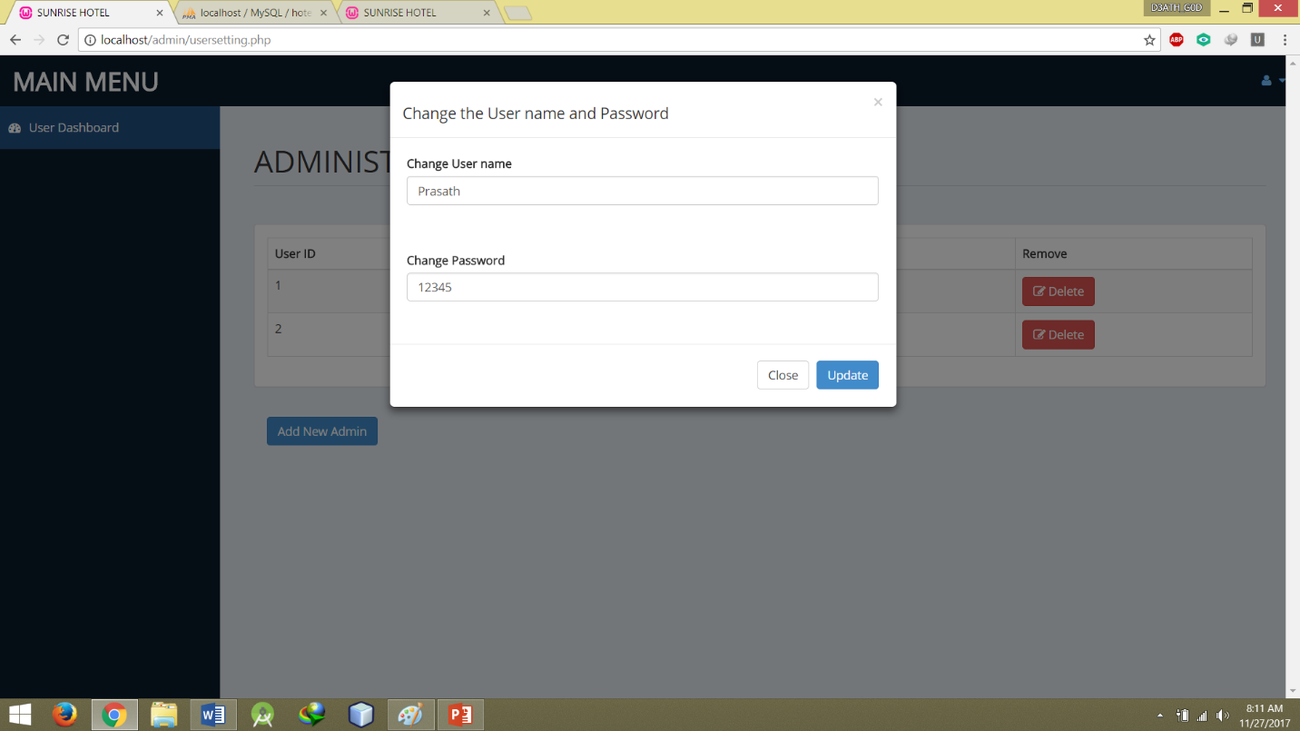

4.4 Triggers
4.5 Stored Procedure
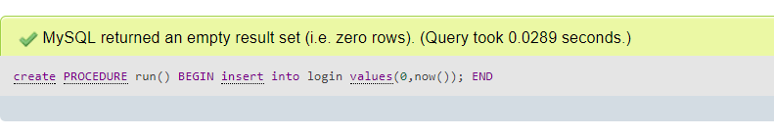
Snapshots
Login Page
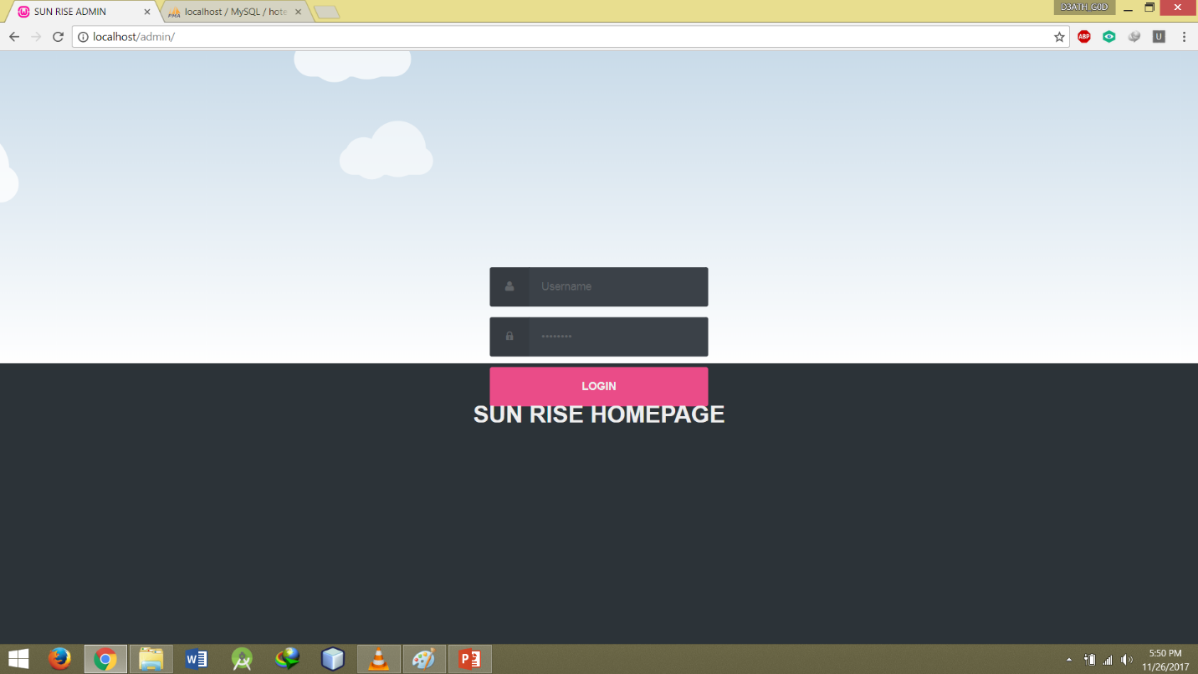

Status Checking
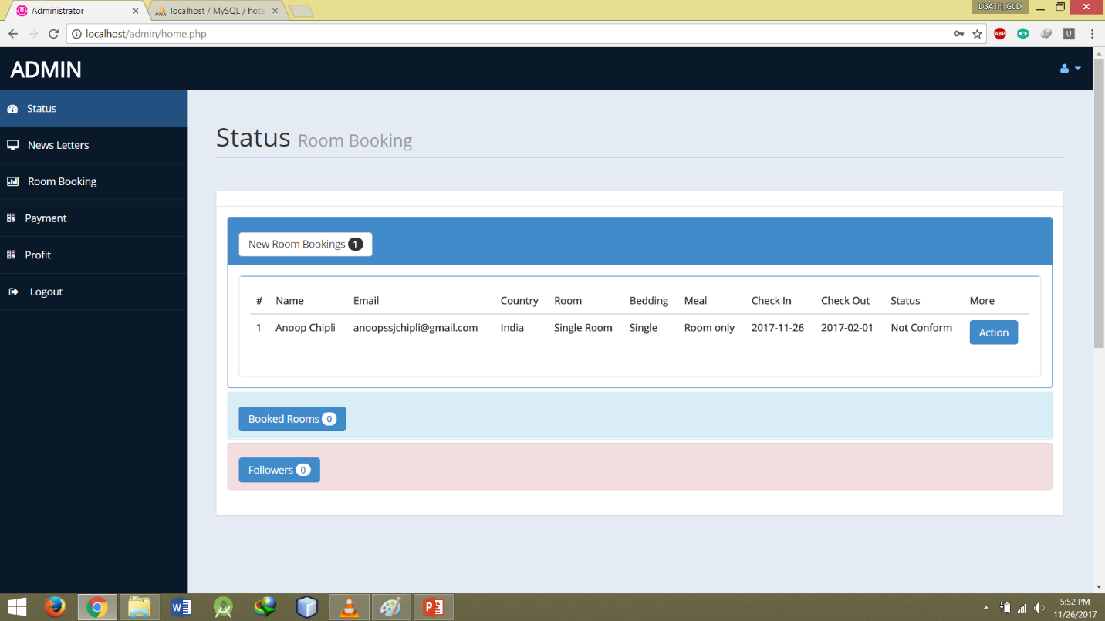
Room Booking
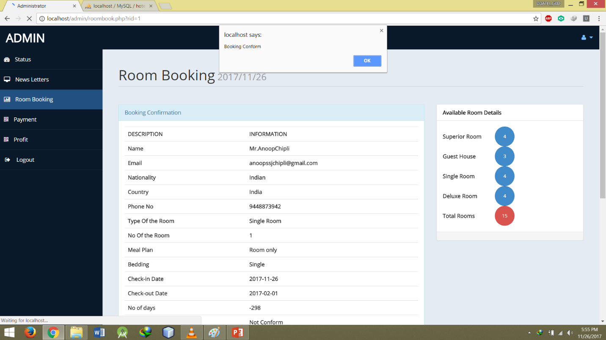

Fetching the Info
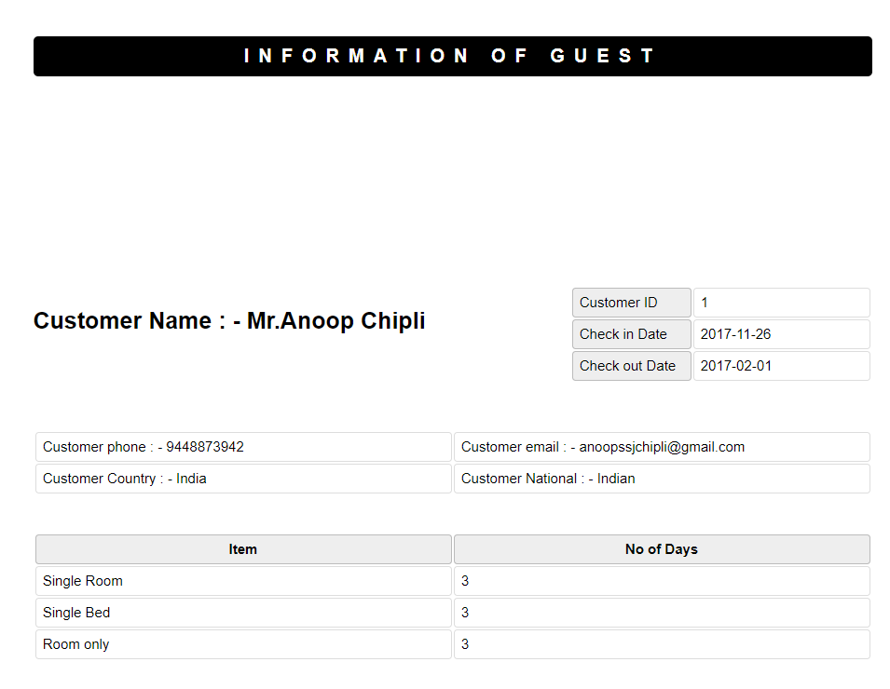

Checking the payment info
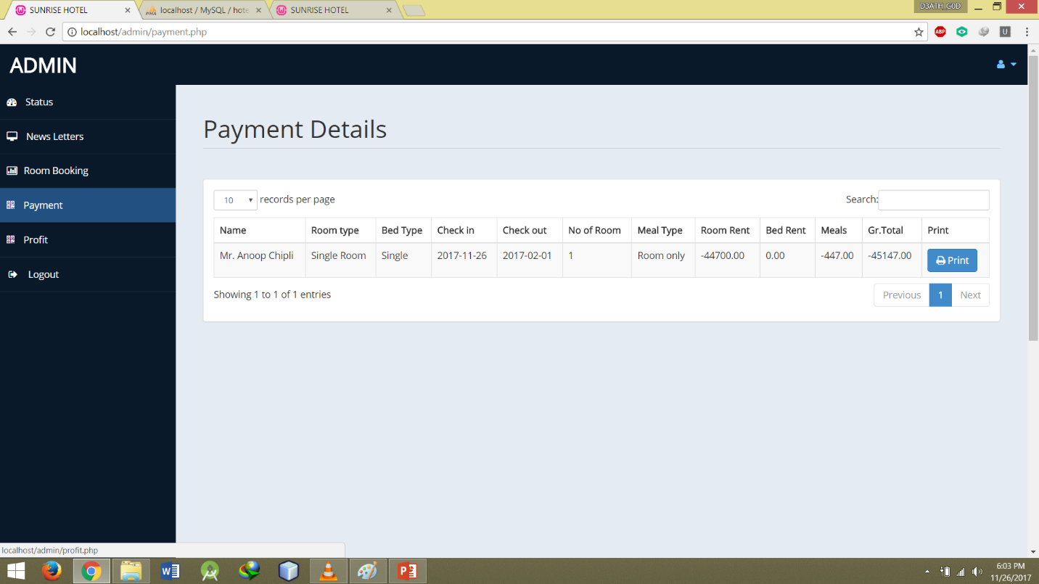

Conclusion
It has been a matter of immense pleasure, honor and challenge to have this opportunity to take up this project and complete it successfully. While developing this project I have learnt a lot about hotel management, I have also learnt how to make it user friendly by hiding the complicated parts of it from users. During the development process I studied carefully and understood the criteria for making a software more demanding, I also realized the importance of maintaining a minimal margin for error.

Future Enhancement
There are a lot of things which can be taken care in the project and it can be done in better way. We can perform operations such as room reservation, availability, hall reservation, billing. Now after the web is made available at all the places and the way in which it can be accessed easily and managed comfortably there is a need for a software which can manage everything for hotel room reservation. To implement this, we need a front-end tool which will give a user-friendly end to the customer for easy reservation of the hotel room through online. If we can implement the above situation the project can be used for all the hotel depending on their requirements.

Bibliography
Source obtained from:
www.stackoverflow.com
www.wikipedia.com
www.Msdn.com
www.w3schools.in

